LANDIS-II Dynamic Fire System Extension (v1.0) User Guide

Brian R. Sturtevant¹
Brian R. Miranda¹
Robert M. Scheller²
Douglas Shinneman³

¹USDA Forest Service, Forestry Sciences Laboratory, Rhinelander, WI
²University of Wisconsin-Madison, Madison, WI
³The Nature Conservancy, Duluth, MN

Last Revised: September 22, 2010

Introduction 3
1.1. Fire Occurrence 3
1.2. Event Size 3
1.3. Fire Event Weather 4
1.3.1. Season 5
1.3.2. WSV, FFMC, BUI, WDIR 6
1.3.3. Weather Effects: Initial Spread Index 6
1.4. Rate of Spread 7
1.4.1. Fuel Effects on Spread Rate 7
1.4.2. Fuel Moisture Build-up Index 8
1.4.3. Fire Regime Unit Adjustment (Optional [Mandatory for the moment]) 9
1.5. Fire Burn Region 10
1.5.1. Fire Burned Area: Calculating Spread Rate for Each Cell 10
1.5.2. Fire Burned Area: Complex Time Cost Surface 12
1.6. Non-Forest Fuel Types 12
1.7. Topography (Optional) 13
1.8. Fire Severity 14
1.9. Fire Damage 17
1.10. References 17
1.11. Acknowledgments 18
2. Parameter Input File 19
2.1. LandisData 19
2.2. Timestep 19
2.3. Event Size Type 19
2.4. Build Up Index 19
2.5. WeatherRandomizer (Optional) 19
2.6. Tables of Ecoregion-dependent Parameters 19
2.6.1. EcoCode 20
2.6.2. Ecoregion Column 20
2.6.3. Mu 20
2.6.4. Sigma 20
2.6.5. Maximum Size/Duration 20
2.6.6. Spring FMC Low 20
2.6.7. Spring FMC High 20
2.6.8. Spring High Proportion 21
2.6.9. Summer FMC Low 21
2.6.10. Summer FMC High 21
2.6.11. Summer High Proportion 21
2.6.12. Fall FMC Low 21
2.6.13. Fall FMC High 21
2.6.14. Fall High Proportion 21
2.6.15. Default Open Fuel Type Index 22
2.6.16. Number of Fires 22
2.7. InitialFireEcoregionsMap 22
2.8. DynamicEcoregionTable 22
2.9. GroundSlopeFile (optional) 22
2.10. UphillSlopeAzimuthMap (optional) 22
2.11. Seasons Table 23
2.12. InitialWeatherDatabase 23
2.13. DynamicWeatherTable 24
2.14. Fuel Type Table 24
2.15. SeverityCalibrationFactor 25
2.16. Fire Damage Table 25
2.16.1. Table Name 25
2.16.2. Cohort Age 25
2.16.3. Fire Severity – Fire Tolerance 25
2.17. MapNames 25
2.18. LogFile 25
2.19. SummaryLogFile 26
3. Output Files 27
3.1. Fire Severity Maps 27
3.2. Fire Event Log 27
3.3. Fire Time Step Log 27
4. Sample Input File 28

Introduction
This document describes the Dynamic Fire System extension for the LANDIS-II model. For information about the model and its core concepts, see the LANDIS-II Conceptual Model Description. A description of this extension has been published in Ecological Modelling (Sturtevant et al. 2009), see References below.

Fire Occurrence
Fire starts are based upon the hierarchical fire frequency model of Yang et al. (2004) that divides fire occurrence into two separate events – fire ignition and fire initiation. A fire ignition is defined as the first instantaneous instance of a fire, caused by either natural or anthropogenic sources. Fire initiation is defined as the likelihood that a fire ignition will burn an entire cell, and is a probabilistic function of the fuel conditions of that cell.
At each time step, the number of fire ignitions is drawn for each fire regime unit from a Poisson distribution, with a parameter value λ defined by the user. The value of λ is equal to the average number of ignitions within the fire regime unit per time step. The number that is drawn from the distribution is the number of ignitions that will be attempted for that time step.
For each ignition, the fire module randomly selects a cell from the given fire regime unit, and evaluates whether the fire ignition initiates a fire event by comparing initiation probability of the fuel type present on that cell with a uniform random number:
random_{U}(0,1) ≤ P_{FuelType} → fire event starts (Eq. 1)
where P_{FuelType} is a user-defined parameter between 0 and 1 (default = 1) defined for each fuel type.

Event Size
The fire module determines individual fire sizes and shapes using spread equations adapted from the Canadian Forest Fire Behavior Prediction System (FBP; Forestry Canada Fire Danger Group 1992) and an adaptation of the minimum travel time method described by Finney (2002), combined with a predetermined fire size or duration defined in Section 2.3. The fire spread algorithm entails two components: wind bias, and fuel-based spread. The wind bias component assumes an ellipsoidal shape with dimensions (i.e., length, breadth) dependent on wind speed. The fuel-based spread component is determined by a combination of fuel class (derived from a fuel module), wind strength, and topography. The wind bias and fuel-based spread combine to calculate the total spread rate, which incorporates fuel class, wind speed, wind direction, topography and the location of the pixel relative to the source pixel. The inverse of the spread rate is used as a cost surface to calculate minimum travel time to cross each pixel. The cumulative minimum travel time determines the final shape of an individual fire patch based on a cutoff determined by either a predetermined fire size or duration.

This fire module has two options for controlling the size of a fire for a given fire event: size-based and duration based. Former versions of LANDIS used a size-based option, i.e., once a fire was initiated, a fire size was randomly selected from a user-defined lognormal distribution, and the fire spread until it either reached that size or ran out of cells that can burn (He and Mladenoff 1999). When the size-based option is applied in this fire module, burned sites are selected in order of increasing minimum cumulative travel time until the number of sites selected multiplied by the cell area equals or exceeds the predetermined fire size.
Alternatively, this fire module can randomly select a fire duration from a user-defined distribution, an approach first applied within Fin-LANDIS (Pennanen and Kuulaivanen 2002) that allows the fire regime (i.e., fire size distribution and fire rotation) to be influenced by the landscape configuration of fuels. When the duration-based option is applied in this fire module, all sites with a minimum cumulative travel time that is less than or equal to the predetermined fire duration are selected to become the burned area for that individual fire event.
Both fire sizes and fire durations are assumed to follow a lognormal distribution, with parameters μ (Mean Fire Size: MFS; or Mean Fire Duration: MFD), σ² (Standard Deviation of Fire Size: SDS; or Standard Deviation of Fire Duration: SDD), and maximum (size or duration) to simulate fire spread. Minimum size or duration is assumed to be zero. Size units are in hectares, and duration units are in minutes. The above distributions can be parameterized independently for each fire regime unit.
When a fire size or duration is selected, a size or duration class is assigned to the event based on the likelihood of that size or duration being selected from the distribution. Five size/duration bins are defined by the percentiles listed below (Table 1; from MN DNR). The size/duration class is used to link fire size or duration to fire weather (Section 1.3)
Table 1. Fire size/duration classes based on percentiles.
Description | Class | Probability | Percentile
Extreme | 5 | 2.5% | 97.5
Very High | 4 | 7.5% | 90
High | 3 | 13.5% | 76.5
Moderate | 2 | 30% | 46.5
Low | 1 | 46.5% | 0

Fire Event Weather
In this fire extension, the weather associated with a fire event is assumed to be related to the size or duration of the fire. This follows the general assumption that larger and longer duration fires tend to occur when fire weather is more favorable for burning, and smaller and shorter duration fires occur when fire weather is unfavorable. This link between size/duration and fire event weather is done by assigning both fire size/duration and weather records to classes based on their frequency. The fire size/duration classes are described above (Section 1.2), and the weather classes are described below.

The fire module requires the following weather input: season (spring, summer, fall), leaf status (leaf-on, leaf-off), wind speed velocity (WSV) in km per hour, wind direction (WDIR) in degrees, fine fuel moisture code (FFMC), the Buildup Index (BUI), and the percent curing. FFMC and BUI are indices calculated as part of the Canadian Forest Fire Weather Index System (Van Wagner 1987). Fire weather inputs are provided by the user in a database defined in the parameter file. The current version defines the weather conditions to be constant for the entire event. Users can allow the fire weather distributions to change over time throughout the simulation by using different databases at different timesteps.
For each season, representative daily values of WSV, FFMC, BUI, and WDIR are required for each fire ecoregion. These components are supplied as a table of daily weather records for each season within a comma-separated value (csv) file. The table should contain fields labeled “FFMC” (Fine Fuel Mositure Code), “BUI” (Build-Up Index), “WSV” (Wind Speed Velocity), “WINDDir” (Wind Direction), “FWIBin”, “Season”, and “Ecoregion”. Each row should represent a daily record of weather data representative of the specified fire ecoregion and season. Season names should be capitalized, and ecoregion names should match those listed in the ecoregion table (see Section 2.6) exactly (capitalization matters). FFMC, BUI, and WSV fields must have decimal values for the first record, because the format of the data is determined by reading the first line. If the values in the first row are actually integers, it is best to add a small decimal (e.g., 0.001) to each value so that the program will recognize those fields as decimal fields. You will receive a “cast” error if the program interprets the fields as integers.
In addition to the WSV, FFMC, BUI, and WINDDir, each record should contain a field labeled “FWIBin”, which identifies the class (1-5) used to link the weather records to size/duration classes. Class 5 should include weather records with the most extreme fire weather, and Class 1 should include records with the least favorable fire weather. Users can assign the classes in any manner, though the original intent was to use the Fire Weather Index (FWI) as a means for ranking. FWI can be calculated using WSV, FFMC, and BUI (Van Wagner 1987). The percentiles in Table 1 above can be used to put weather records into classes based on FWI values. The fire weather table must contain at least 1 record in each FWIBin is required for any season and ecoregion that has a fire ignition rate (Section 1.1) greater than zero.
The csv file that provides the weather data can change during the course of the simulation. This allows users to have different weather distributions represented at different times. This option is useful for modeling climate change scenarios.

Season
The fire module selects the season for a fire event based on the proportion of fires that occur within each season, defined by the user. The selection of season defines the leaf status for the fire event. By default, spring and fall seasons are considered leaf-off, and summer is considered leaf-on. These values can be changed by the user.

WSV, FFMC, BUI, WDIR
The fire module selects the wind speed velocity (WSV), fine fuel moisture code (FFMC), buildup index (BUI), and wind direction (WDIR) for a fire event based on daily weather records supplied by the user. For each of the season-ecoregion combinations (spring, summer, fall for each ecoregion), the user defines a table of daily weather. After the fire size/duration has been selected for the event, the program randomly selects a record from the appropriate ecoregion-season table that have specific fire weather classes (FWIBin) relative to the assigned size/duration class. Which FWIBins can be selected is controlled using the optional Weather Randomizer. The default weather randomizer (0) allows only the exact corresponding FWIBin (same bin value as selected size/duration bin) to be selected. Larger values for the weather randomizer (up to 4) allow the selection of weather records from additional adjacent weather bins. A weather randomizer value of 4 completely eliminates the link between fire size/duration bins and FWIBins. The values for WSV, FFMC, BUI, and WDIR for the event are read from the selected record.
Wind Direction Note: The value for wind direction in this extension should be considered carefully. Normally, wind direction reported from weather stations is the direction that the wind is coming from. In all calculations in this extension, we require the direction that the wind is blowing to. Therefore, the weather station wind directions may need to be adjusted by 180 degrees before calculating wind direction probabilities.

Weather Effects: Initial Spread Index
Equation numbers in parentheses preceded by “FBP” refer to the corresponding equation numbers in Forestry Canada Fire Danger Group (1992). Spread rate calculations begin with initial spread index (ISI) based on Van Wagner (1987):
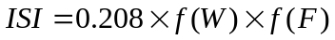 (FBP; 52)
where the fuel moisture effect 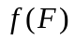is:
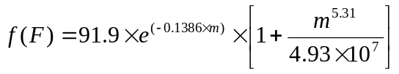 (FBP; 45)
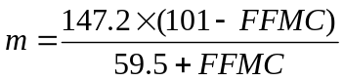 (FBP; 46)
The wind effect 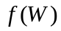is:
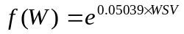 (FBP; 53)
Where WSV exceeds 40 km/hr:
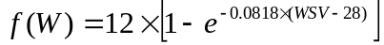 (FBP; 53a)

Rate of Spread
The combination of fuel type, wind strength, fuel moisture conditions, and (optionally) topography determines the fuel-based spread component. The fuel type is determined through the separate fuel extension (Dynamic Fuel System extension), which evaluates species/age composition to assign fuels to user-defined fuel types. The fuel type-specific rates of spread are calculated using equations from the Canadian FBP (Forestry Canada Fire Danger Group 1992), although users can alter input parameters to accommodate any fuel type.
Each user-defined fuel type (see Section 2.14) identifies a base fuel type (conifer, deciduous, conifer plantation, slash, open) and a surface fuel type (C-1 to C-7, D-1, S-1 to S-3, O-1a, O-1b) which define the fire behavior of each fuel type. Users are free to adjust inputs. For simplicity in this users guide, we will address fuels as if they match directly with Canadian FBP types, though the same logic and equations apply to other fuel types. For example, when we address fuel type C-1, the referenced equations will apply to any fuel type that has a surface fuel type defined as C-1.

The current fire module assumes that fires instantly reach equilibrium rates of spread. Future versions of the module might account for acceleration and deceleration periods affecting fire spread (i.e., Equations 70-73; Forestry Canada Fire Danger Group 1992). However, they are not implemented here.

Fuel Effects on Spread Rate
For conifer fuel types (C-1 to C-7), leafless deciduous (D-1), and slash (S-1, S-2, and S-3), the initial rate of spread (RSI):
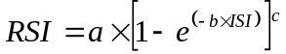 (FBP; 26)
where a, b, c are fuel type-specific coefficients listed in the Fuel Type Table (see section 2.14). Leaf-on deciduous is assumed to be 20% of leaf-off spread rates.
For mixed conifer-deciduous, the rate of spread is assumed to be a blend of a conifer type (C-1 to C-7) and D-1. For M-1 (leaf-off):
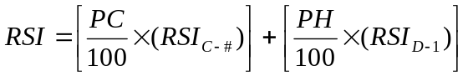 (FBP; 27)
Where PC = percent conifer and PH = percent hardwood. The FBP equations for M-1 and M-2 use only the conifer type C-2. In this extension, we allow the mixing of any conifer type in the M-1 and M-2 fuel types.
For Fuel Type M-2 (leaf-on), apply the same assumption that the deciduous component will burn at 20% of the leaf-off spread rate:
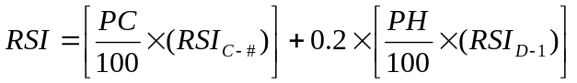 (FBP; 28)
For fuel type M-3 (dead balsam fir mixedwood leaf-off), calculate coefficients as:
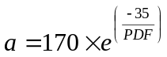 (FBP; 29)
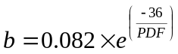 (FBP; 30)
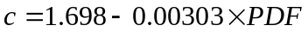 (FBP; 31)
Where PDF = percent dead fir (or other conifers). PDF is calculated by the fuel extension based on the number of dead conifer cohorts, which is provided by the BDA or other disturbance extension.
For fuel type M-4 (dead balsam fir mixedwood leaf-on), calculate coefficients as:
(FBP; 32)
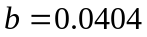 (FBP; 33)
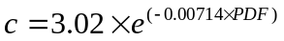 (FBP; 34)
The rate of spread in Open Fuel Types (O-1a, O-1b) is dependent on the degree of curing (i.e., the percentage of dried stems):
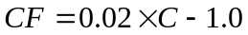 C>50 (FBP; 35)
where CF is the grass curing coefficient and C is the degree of curing (%). When C ≤ 50, CF = 0. Hence the initial rate of spread for Open Fuel Types is:
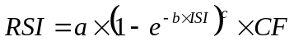 (FBP; 36)
CF is determined by season based on the user input (see Section 2.11).
Note: The above equations, in combination with the season of burn, and some assumptions regarding the curing coefficient, give users the opportunity to capture the essence of wetland burn rates (i.e., wetlands will only burn when drawdown is sufficient to dry surface material – much more likely in late summer/fall).

Fuel Moisture Build-up Index
A buildup index (BUI) modifies spread rates to account for longer weather time lags than FFMC (i.e., 10-day time lag). The use of BUI to influence rate of spread is optional (see Section 2.5). The influence of BUI on rate of spread is dependent on the fuel type, and is expressed as the buildup effect (BE):
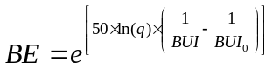 (FBP; 54)
BUI is the weather-derived Build Up Index (see Section 1.3.2); BUI₀ is the average BUI for the particular fuel type from the Fuel Type Table (Section 2.14).
Rate of spread can then be calculated for all types except C-6 as the following:
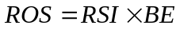 (FBP; 55)

Conifer Plantations (Fuel Type C-6): Rate of spread (ROS) equations for conifer plantations are different than other fuel types following the calculation of RSI. For C-6 fuels:
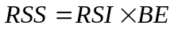 (FBP; 63)
where RSS is the surface fire rate of spread.
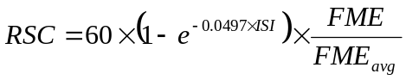 (FBP; 64)
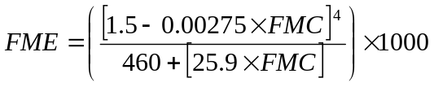 (FBP; 61)
where FME_{avg} is 0.778, and FMC is foliar moisture code (see Section 1.8, Fire Severity).
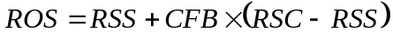 (FBP; 65)
where CFB is crown fraction burned (see Section 1.8, Fire Severity). ROS is equivalent to the rate of spread (m/min) if the site is directly downwind from the source cell.

Fire Regime Unit Adjustment (Optional [Mandatory for the moment])
Because fire regimes are parameterized independently for each fire regime unit, it is possible for fires starting in one fire regime unit to spread into another. This can affect the integrity of the individual fire regimes. The fire size distribution of the fire regime unit can be preserved by relativizing the spread rates according to the mean fire size or duration of the unit where the fire started.
For a size-based fire regime:
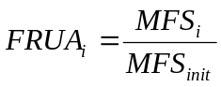
For a duration-based fire regime:
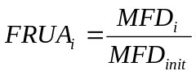
For that particular fire event, rates of spread for each cell in fire management unit i are recalculated as:
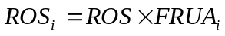
This adjustment will cause fires to burn relatively more area within fire prone units than fire resistant units for a given fire event. However, the original spread rates will be used to calculate fire severity (see Section 1.8).

Fire Burn Region
The burned area for a fire event is determined by selecting cells based on the time it would take the fire to reach each cell from the ignition (i.e., minimum travel time). The total travel time is calculated starting from the ignition location. The program calculates the travel time to each active neighbor cell (8 cells maximum), and chooses the cell with the lowest cumulative travel time. The program then treats that chosen cell as the fire source and calculates the travel time to each of its active neighbor cells, and chooses the cell with the lowest cumulative travel time. This process continues until the cumulative travel time exceeds the selected event duration or the number of cells checked exceeds the selected event size. The program repeats this process multiple times to ensure that the chosen spread sequence results in the calculation of the actual minimum travel times for each cell.
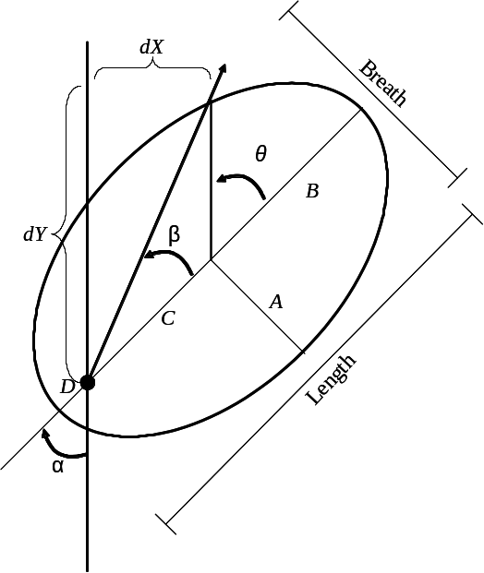
Figure 1. Main features of a fire ellipse (adapted from Finney 2002).

Fire Burned Area: Calculating Spread Rate for Each Cell
Fire spread is limited to each cell’s 8 adjacent neighbor cells. The cell that the fire is spreading from is the source cell (beginning with the initiation site), and the cell that the fire is spreading to is the target cell. Calculating actual rates of spread begins with β, the angle formed between the wind direction (α) and the line between the source and target cells (see Figure 1).

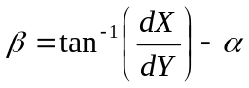 (Finney 2002; Eq. 4)
where dX is the difference in row numbers between the source cell and the target cell; dY is the difference in column numbers. Note: if dY is less than zero, add 180 to β. To reduce artifacts of shape that can occur with the limitation of spreading to only to 8 neighbors, the β angle is stochastically varied within a range of ± 22.5 degrees.
The length-to-breadth ratio (LB) for the fire event ellipse is determined by the selected WSV for the event.
For all fuel types except O-1:
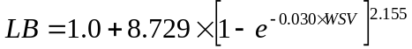 (FBP; 79)
For open fuel types (O-1):
If WSV ≥ 1.0:
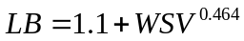 (FBP; 80)
If WSV < 1.0:
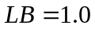 (FBP; 81)
The lengths of A, B, C (Figure 1) are dependent on the distance between the source and target cells, and on LB. To calculate A, B, C we use components of the polar equation for an ellipse. First calculate the eccentricity (e).
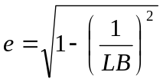
Next, calculate the semi-latus rectum (p), which is the distance from the focus to the ellipse perimeter perpendicular to the major axis.
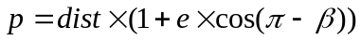
where dist is the distance between the source cell center and the target cell center. Once p is calculated, we can calculate B and C.
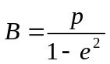
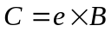
B + C is the distance the fire would travel in the downwind direction from the rear focus of the ellipse. Given the rate of spread in the downwind direction (ROS_{i}) calculated above, we can calculate the time it would take to travel a distance of B + C.
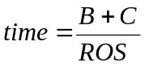
We know the distance that the fire must travel in the direction of the source cell (dist), and the time it should take to travel that distance (time), so we can calculate the average rate of spread in that direction (DirROS).
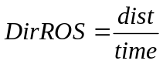

Take the inverse of DirROS to estimate the spread time “cost” in minutes per meter in that cell.

Fire Burned Area: Complex Time Cost Surface
The direction of travel for a fire front changes in response to heterogeneous fuels and topography and the presence of non-forested (barrier) cells. Therefore, we developed an algorithm that accounts for the length of the path required for fire to spread to each cell.
For each cell within the defined maximum distance (circle or ellipse), the algorithm searches for the neighbor with the shortest travel time. For the eight cells surrounding the ignition point, this shortest travel time will be zero. The neighbor travel time is added to the travel time (1/AdjROS, above) calculated for each cell. The travel time is also adjusted to account for the cell size and relative distance from the neighbor to the cell (multiplied by [1.0 * cell size] for adjacent cells, [~1.4 * cell size] for diagonal neighbors).
This neighborhood distance calculation is made once when the cells are recursively added during spreading. The travel times for each cell are checked for potentially shorter travel routes by iteratively searching for valid neighbors with shorter travel times. The list is searched up to 2000 times for shorter routes.
Once minimum travel time has been calculated for each site, the predetermined fire size or duration is used to identify which sites are included in the burned area. For size-based regimes, cells are added to the burn area in order of increasing time cost until the predetermined fire size is reached. For duration-based fires, all sites with a minimum travel time that is less than or equal to the predetermined fire duration are selected to become the burned area for that individual fire event.

Non-Forest Fuel Types
Active sites may include non-forested sites that will burn. Key examples include grassland, shrubland, and some wetland cover types that have establishment coefficients of zero (0) for all tree species. These active, non-forest sites can be defined in the FireEcoregions input table in the Fire Extension. User input fuel types can then be assigned to non-forest, fire ecoregions. For instance, grassland fire ecoregions can be assigned to an open-fuel type and shrubland fire ecoregions may be compatible with a deciduous fuel type. These fuel types may be subject to additional seasonal parameters, as determined in the Fire Extension. If fire ecoregions are not used in the Fire Extension, or if the user does not assign a fuel type to a non-forest, fire ecoregion, the active sites within those fire ecoregions will not be assigned to a fuel type and will not burn.

Topography (Optional)
Topography influences spread rates in a similar way as wind, so the effects of topography on spread can be modeled as wind factors. If the topographic effects option is turned on, the following equations calculate initial spread rates with slope influence (ISF) which substitutes for ISI in the above rate of spread equations.
Topographic effects on fire spread rates are based on the equation from Van Wagner (1977):
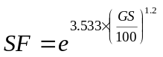 (FBP; 39)
where SF is the topography spread factor, and GS is the ground slope in percent. Note that the above equation is not recommended to apply to slopes greater than 60%.
First calculate the zero wind rate of spread (RSZ) within all cells falling within the Maximum Fire Event Region, using the above ISI equations, a wind speed of 0 km/hr, the FFMC, and the fuel type present on the cell (Forestry Canada Fire Danger Group 1992). The slope factor is then multiplied by this value to derive the “slope-adjusted zero wind rate of spread” (RSF):
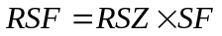 (FBP; 40)
Next calculate the ISI with slope influence and zero wind:
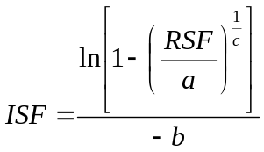 (FBP; 41)
where a, b, c are fuel-type-specific rate of spread equation constants.
Equation FBP 41 will not work for two fuel type groups: mixedwood (M-1 and M-2) and grass (O-1). For fuel types M-1 and M-2:
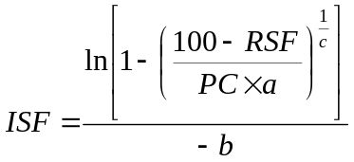 (FBP; 42)
where a,b,and c are fuel-type specific rates of spread for the softwood (C-2) component, and PC is percent conifer composition. For the O-1 fuel type:
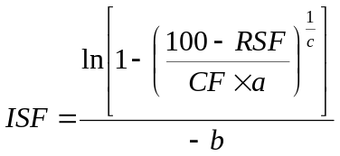 (FBP; 43)
where CF = the percent cured/dead material factor from FBP Eq. 35.
Next compute the slope equivalent wind speed (WSE):
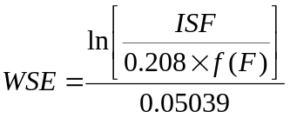 (FBP; 44)
where f(F) is the fuel moisture effect (see Section 1.3.3,; FBP 45, 46). WSE is the effect the percent slope would have on the rate of spread if it were a wind speed. This effect can be added to the wind speed along a transect between cell points by calculating percent slope from the difference in elevation between the cell points, adjusting the distance calculation to account for elevation change, calculating WSE using the equations in this section, using vector addition to combine the wind and slope effects, and then calculating rate of spread and travel time.
The vector addition uses the following equations:
WSX = [WS * sin(WAZ)] + [WSE * sin(SAZ)] (FBP; 47)
WSY = [WS * cos(WAZ)] + [WSE * cos(SAZ)] (FBP; 48)
WSV = √(WSX² + WSY²) (FBP; 49)
RAZ = arccos (WSY/WSV) (FBP; 50)
If WSX < 0, then RAZ = 360 – RAZ (FBP; 51)
where WS is wind speed velocity, WAZ is the wind azimuth, SAZ is the uphill slope azimuth, WSV is the net effective wind speed, and RAZ is the net effective wind direction. This net effective wind speed and direction is then used for all subsequent calculations involving a wind speed or direction, including ISI and LB.

Fire Severity
At each site, a fire event will have a unique severity that is a user-defined function of the rate of spread (ROS) and the critical surface fire rate of spread (RSO), above which fires begin to reach the crown. Both affect fire intensity.
Crown Base Height (CBH) and foliar moisture code (FMC) are used to calculate the Critical Surface fire Intensity (CSI). CBH is defined by the user for each fuel type. FMC is dependent on location (lat/long), elevation, and Julian date. This value is defined by the user for each season by landtype, in the landtype table. The user can define 2 FMC values for each season, since phenology-based seasons do not necessarily coincide with the seasonality of FMC. This requires the user to define what proportion of fires within the landtype should be associated with each of the sub-season values. The user can choose to not divide the seasons by making one of the proportions equal to 1.0. See Figure 2 for an example of the seasonality of FMC and its relationship to phenology-based seasons.
Figure 2. Foliar moisture code (FMC) seasonality and corresponding phenology-based seasons.
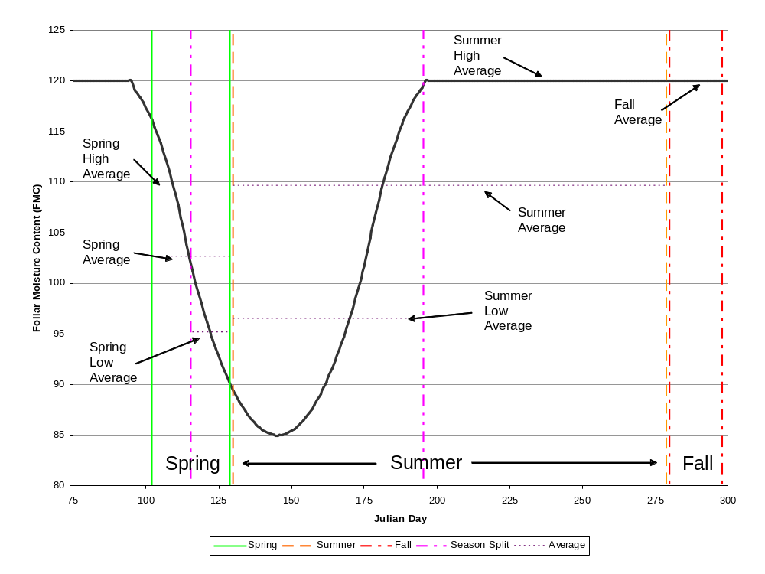
Next, the Crown Fraction Burned (CFB) is calculated:
CSI = 0.001 * CBH^{1.5}*(460 + 25.9 * FMC)^{1.5} (FBP;56)
RSO = CSI/(300 * SFC) (FBP;57)
CFB = 1 – e^(-0.23 * (ROS – RSO)) (FBP;58)
Where Surface Fuel Consumption (SFC) is calculated using the following equations for each fuel type.
For C-1:
SFC = 1.5*(1-e^{(-0.2230 * [FFMC - 81])}), (FBP;9)
if SFC <0, then set SFC = 0
For C-2, M-3, M-4:
SFC = 5.0 * (1-e^{(-0.0115 * BUI)}) (FBP;10)
For C-3, C-4:
SFC = 5.0 * (1-e^{(-0.0164 * BUI)})^{2.24} (FBP;11)
For C-5, C-6:
SFC = 5.0 * (1-e^{(-0.0149 * BUI)})^{2.48} (FBP;12)
For C-7, forest floor consumption (FFC) and woody fuel consumption (WFC) are calculated separately, and summed to get SFC:
FFC = 2 * (1-e^{(-0.104*(FFMC - 70)}) , (FBP;13)
If FFC <0, then set FFC = 0
WFC = 1.5 * (1-e^{(-0.0201 * BUI)}) (FBP;14)
SFC = FFC + WFC (FBP;15)
For D-1:
SFC = 1.5 * (1-e^{(-0.0183 * BUI)}) (FBP;16)
For Mixed fuel types (percent hardwood greater than zero):
SFC = (PC/100 * (SFC for C-2 through C-7)) + (PH/100 * (SFC for D-1)) (FBP;17)
For O-1:
SFC = GFL (FBP;18)
Grass fuel load (GFL) has a standard value of 0.3 kg/m²
For S-1:
FFC = 4.0 * (1-e^{(-0.025 * BUI)}) (FBP;19)
WFC = 4.0 * (1-e^{(-0.034 * BUI)}) (FBP;20)
For S-2:
FFC = 10.0 * (1-e^{(-0.013 * BUI)}) (FBP;21)
WFC = 6.0 * (1-e^{(-0.060*BUI)}) (FBP;22)
For S-3:
FFC = 12.0 * (1-e^{(-0.0166*BUI)}) (FBP;23)
WFC = 20.0 * (1-e^{(-0.0210 * BUI)}) (FBP;24)
For S-1, S-2, S-3:
SFC = FFC + WFC (FBP;25)
Finally, the fire severity is defined by the crown fraction burned (CFB), ROS, and RSO. An index of 1-5 is calculated, with 1 being the least severe and 5 being the most severe:
Class 5 has CFB >= 0.9
Class 4 has 0.495<= CFB < 0.9
Class 3 has 0.1<=CFB<0.495.
Classes 1 and 2 both have CFB < 0.1.
Class 2 has a ROS >= (RSO + 0.458) / 2.
Class 1 has a ROS < (RSO + 0.458) / 2.
The Class 1 and 2 threshold value is based on calculating the ROS value required to have CFB = 0.1 (this is when ROS = RSO + 0.458). Then this range of ROS is divided evenly into the 2 classes.

Fire Damage
If fire severity = 5, then all cohorts of all species will be killed. If fire severity < 5, then fire damage is dependent upon the age of the cohorts at each site within an event and the fire tolerance of each species. The youngest cohorts are most vulnerable. For each cohort, the difference between the fire severity and fire tolerance is calculated. The difference determines which cohorts are killed; all cohorts below a User input relative age will be killed.
Table 1. Example of cohort age and the fire severity-fire tolerance differential. The values below were used in all previous LANDIS versions.

Cohort Ages Killed  (% of species longevity) | Severity – Species Fire Tolerance Differential
≤ 20% | -2
≤ 50% | -1
≤ 85% | 0
≤ 100% | 1

Each fire event has an associated mean fire severity which is the average of the severities at all of the event’s sites.

References
Finney, M.A. 2002. Fire growth using minimum travel time methods. Canadian Journal of Forest Research 32: 1420–1424.
Forestry Canada Fire Danger Group 1992. Development and structure of the Canadian Forest Fire Behavior Prediction System. Forestry Canada, Science and Sustainable Development Directorate, Information Report ST-X-3, Ottawa, Ontario, Canada.
He, H.S. and Mladenoff, D.J. 1999. Spatially explicit and stochastic simulation of forest-landscape fire disturbance and succession. Ecology 80: 81-99.
Pennanen, J. and Kuuluvainen, T. 2002. A spatial simulation approach to natural forest landscape dynamics in boreal Fennoscandia. Forest Ecology and Management 164: 157-175.
Sturtevant, B.R., Scheller, R.M., Miranda, B.R., Shinneman, D., Syphard, A. 2009. Simulating dynamic and mixed-severity fire regimes: A process-based fire extension for LANDIS-II. Ecological Modelling 220: 3380-3393.
Van Wagner, C. E. 1987. Development and structure of the Canadian Forest Fire Weather Index System. Canadian Forest Service, Ottawa, Ontario. Forestry Technical Report 35.
Yang, J., He, H.S., and Gustafson, E.J. 2004. A Hierarchical Fire Frequency Model to Simulate Temporal Patterns of Fire Regimes in Landis. Ecological Modelling 180: 119-133.

Acknowledgments
Funding for the development of LANDIS-II has been provided by the North Central Research Station (Rhinelander, Wisconsin) of the U.S. Forest Service. Valuable contributions to the development of the model and extensions were made by Eric J. Gustafson, and David J. Mladenoff.

Parameter Input File
Most of the input parameters for this extension are specified in one input file. This text file must comply with the general format requirements described in section 3.1 Text Input Files in the LANDIS-II Model User Guide.

LandisData
This parameter’s value must be "Dynamic Fire System".

Timestep
This parameter is the extension’s timestep. Value: integer > 0. Units: years.

Event Size Type
Must be either ‘size_based’ or ‘duration_based’.

Build Up Index
The Build Up index is either turned on or off. Values of ‘Y’ or ‘yes’ turn BUI on, and ‘N’ or ‘no’ turns BUI off. Having BUI turned off means BE will always be 1.0 and therefore not impact spread rates.

WeatherRandomizer (Optional)
The weather randomizer controls the strength of the linkage between the size/duration distribution and the weather distribution. This parameter is optional, with the default being a full-strength linkage, equivalent to a parameter value of 0. A full strength linkage means that the weather record will always be chosen from the same bin (1-5) as the size/duration bin. Values greater than 0 for this parameter allow the weather record to be selected from bins surrounding the selected size/duration bin. The weather record can then be selected from bins in the range (SizeBin ± value). A parameter value of 4 means that there is no link between the size/duration and the weather data.
Value: 0 ≤ integer ≤ 4.

Tables of Ecoregion-dependent Parameters
The input file has a table of ecoregion-dependent parameters. Each row in a table contains the parameters for one ecoregion.

EcoCode
The first column in the table contains ecoregion map codes. The values must match the map values in InitialFireEcoregionsMap (2.7) and any maps listed in the DynamicEcoregionTable. Any map value that is not listed in this table will be assigned the default value of zero for all parameters.

Ecoregion Column
The second column in the table contains ecoregion names.

Mu
This parameter defines the location parameter of the lognormal distribution of fire sizes/durations for the ecoregion. This value is equivalent to the mean of the associated normal distribution. Expected mean for the lognormal distribution can be calculated as: e(^{µ + σ^2)/2}
Value: number ≥ 0. Units: hectares or minutes.

Sigma
This parameter defines the scale parameter of the lognormal distribution of the fire sizes/durations for the ecoregion. This value is equivalent to the standard deviation of the associated normal distribution. Expected standard deviation for the lognormal distribution can be calculated as: √((e^{σ^2} – 1)* e^{2µ + σ^2})
Value: number ≥ 0 Units: hectares or minutes.

Maximum Size/Duration
This parameter defines the maximum size or duration that can be selected from the lognormal distribution. If a value higher than the maximum is selected, another value will be selected until one that is less than or equal to the maximum is chosen. Users who do not wish to truncate the lognormal distribution can set the maximum value to be extremely high relative to expected values.

Spring FMC Low
Foliar moisture content for the portion of the spring season with lower values for the ecoregion.
Value: 0 ≤ number. Units: %

Spring FMC High
Foliar moisture content for the portion of the spring season with higher values for the ecoregion.
Value: 0 ≤ number. Units: %

Spring High Proportion
The proportion of fires within the spring season that occur during the “high” FMC period. Spring Low Proportion is calculated as 1.0 – Spring High Proportion.
Value: 0.00 ≤ number ≤ 1.00 Units: Proportion

Summer FMC Low
Foliar moisture content for the portion of the summer season with lower values for the ecoregion.
Value: 0 ≤ number. Units: %

Summer FMC High
Foliar moisture content for the portion of the summer season with higher values for the ecoregion.
Value: 0 ≤ number. Units: %

Summer High Proportion
The proportion of fires within the summer season that occur during the “high” FMC period. Summer Low Proportion is calculated as 1.0 – Summer High Proportion.
Value: 0.00 ≤ number ≤ 1.00 Units: Proportion

Fall FMC Low
Foliar moisture content for the portion of the fall season with lower values for the ecoregion.
Value: 0 ≤ number. Units: %

Fall FMC High
Foliar moisture content for the portion of the fall season with higher values for the ecoregion.
Value: 0 ≤ number. Units: %

Fall High Proportion
The proportion of fires within the fall season that occur during the “high” FMC period. Fall Low Proportion is calculated as 1.0 – Fall High Proportion.
Value: 0.00 ≤ number ≤ 1.00 Units: Proportion

Default Open Fuel Type Index
The index for the fuel type that will be used to calculate spread rates if no species-age cohorts are present on a cell within the ecoregion. The index value should match an index value from the Fuel Type Table (2.14).
Value: 1 ≤ number ≤ n (number of fuel types) Units: Integer

Number of Fires
The number of fires expected per year within the ecoregion. This value is multiplied by the timestep and used as λ for the Poisson distribution.

InitialFireEcoregionsMap
This parameter is the input map showing where the fire ecoregions are located on the landscape. Each cell value must be one of the map codes listed in the fire ecoregions table (2.6). This map can be the same as the succession ecoregion map.

DynamicEcoregionTable
This table enables the user to allow fire ecoregions to change spatially through the course of a simulation. The first column represents the simulation timestep (year) when the new map should be applied. The second column gives the filename of the new fire ecoregion map. The InitialFireEcoregionsMap will be applied until the timestep reaches the first year listed in the table. The new map will be applied until the timestep reaches the next year listed in the table. If no additional files are listed, the program will continue using the current fire ecoregion map. Use of the DynamicEcoregionTable is optional. If no additional maps are included in this table, the program will use the InitialFireEcoregionsMap for the entire simulation.

GroundSlopeFile (optional)
This optional parameter specifies a raster map to represent percent ground slope. The map should have integer values representing percent slope on the ground. If this map is included, the UphillSlopeAzimuthMap (2.10) must also be included.

UphillSlopeAzimuthMap (optional)
This optional parameter specifies a raster map to represent the direction of uphill slope. Values in this map should be integers ranging from 0 to 360 degrees, specifying the direction upslope. Note: this is the opposite of the way aspect is commonly defined. This parameter should only be specified if GroundSlopeFile (2.9) is specified, if which case this parameter is required.

Seasons Table
The seasons table must include an entry for each of the three seasons: spring leaf off, summer leaf-on, fall leaf-off. For each season, the following parameters must be provided:
parameter name | Units | description
Season Name | text | Names of the three seasons. Must be “Spring”, “Summer”, or “Fall”.
Leaf Status | text | Either “LeafOn” or “LeafOff”
Proportion | 0.0 ≤ double ≤ 1.0 | The proportion of fires that happen within each season
Percent Curing | 0 ≤ integer ≤ 100 | The degree of curing for grasses (%).
Daylength Proportion | 0.0 ≤ double ≤ 1.0 | The proportion of the 24-hour day that fires can actively spread. This parameter only affects duration-based simulations. Users who are using durations based on actual spreading times, rather than ignition to extinguishment times that span multiple days, may want to use a value of 1.0.

InitialWeatherDatabase
This parameter specifies the name of a Comma-separated text file (.csv) that contains the season weather data. The table should contain fields labeled “FFMC” (Fine Fuel Mositure Code), “BUI” (Build-Up Index), “WSV” (Wind Speed Velocity),“WINDDir” (Wind Direction), “FWIBin” (FWI class), “Season”, and “Ecoregion”. Season names (“Spring”, “Summer”, “Fall”) should be capitalized, and ecoregion names should match those listed in the ecoregion table (see 2.6.2) exactly (capitalization matters). Each row should represent a daily record of weather data representative of the specified ecoregion. At least 1 record in each FWIBin (1-5) is required for any ecoregion-season combination that has a fire ignition rate (Section 2.6.16) greater than zero (e.g., a minimum of 5 records). If weather data are assumed to be the same for all ecoregions, “All” can be used in the Ecoregion column to denote that weather records apply to all ecoregions.

DynamicWeatherTable
This table enables the user to allow weather data to change through the course of a simulation. The first column represents the simulation timestep (year) when the new weather data should be applied. The second column gives the filename of the new weather database. The InitialWeatherDatabase will be applied until the timestep reaches the first year listed in the table. The new database will be applied until the timestep reaches the next year listed in the table. The format and naming conventions of tables must be the same as described for the InitialWeatherDatabase (2.12). If no additional files are listed, the program will continue using the current weather database. Use of the DynamicWeatherTable is optional. If no additional files are included in this table, the program will use the InitialWeatherDatabase for the entire simulation.

Fuel Type Table
The fuel type table is mostly copied from Appendix 1 and Tables 6, 7 and 8 of the Canadian Forest Fire Behavior Prediction System (Forestry Canada Fire Danger Group 1992). The fuel type-specific ignition probability (second column) must be determined by the user. Standard values for all other values can be found in the FBP. These parameter values can be adjusted by the user to produce desired behavior, which may be particularly useful if the standard Canadian fuel types to not adequately model certain local fuel types. The fuel type table must have at least 1 entry each with a surface type of M1 and M2, though these types are not defined by the user in the fuel type definitions in the fuel extension. If using the BDA extension, or any other extension that produces dead conifers, the table must also include entries with surface types M3 and M4. These fuel types are required for initiation probability and severity calculations.
2.15.1 Index
The first column in the table (Index), lists an integer index value for each fuel type. The index value in this table should correspond with index values used in the accompanying Fuel Extension. All index values that appear in the Fuel Extension need to be listed in this FuelTypeTable.

2.15.2 BaseType
All fuel types must be assigned to a base type, which can be Conifer, ConiferPlantation, Deciduous, Slash, or Open. The base type defines how the fuels are treated by the extension in calculations of fire spread, conifer dominance, and severity.

2.15.3 SurfaceType
All fuel types must be assigned to a fuel type on which to base surface fuel consumption (SFC) calculations. SFC is used in the calculation of fire severity, and uses fixed equations for each Canadian fuel type. Any custom fuel type needs to be assigned to a similar Canadian fuel type to allow calculation of SFC. Acceptable value for this parameter are C1-C7, D1, M1-M4, S1-S3, O1a, O1b.

SeverityCalibrationFactor
This parameter defines the weight (if any) given to the initial rate of spread (ROS_{i}), relative to the adjusted rate of spread (AdjROS), when calculating severity. A value of 0 makes severity dependent solely on AdjROS. A value of 1.0 weights the two rates equally, and values greater than 1.0 more heavily weight ROS_{i}. Values: number ≥ 0.

Fire Damage Table
This table describes the fire damage classes. The values shown in the example file above were used in all previous LANDIS versions.

Table Name
The table’s name is "FireDamageTable".

Cohort Age
This parameter is the upper bound of the range of cohort ages that a table row applies to. Values: 0% ≤ number ≤ 100%. Units: Percentage of species’ longevity.

Fire Severity – Fire Tolerance
This parameter is the minimum difference between the fire’s severity and the species’ fire tolerance in order for a cohort to be killed by a fire event. Value: integer.

MapNames
This file parameter is the template for the names of the fire severity output maps (see section 3.1). The parameter value must include the variable “timestep” to ensure that the maps have unique names (see Section 3.1.8.1 Variables in the LANDIS-II Model User Guide). The user must indicate if the output should be placed in a sub-directory. Also, the user must indicate the file extension.

LogFile
The file parameter is the name of the extension’s event log file (see section 3.2).

SummaryLogFile
The file parameter is the name of the extension’s summary log file for fire time steps (see section 3.3).

Output Files
The Fire Extension generates two types of output files: a) a map of fire severity for each time step, and b) two log files of fire events for the entire scenario.

Fire Severity Maps
The map of fire severity is labeled 0 for non-active sites, 1 for active and not disturbed sites, 2 for burned sites where no cohorts were damaged, and [fire severity + 2] for all disturbed sites. A map is produced for each fire time step.

Fire Event Log
The event log is a text file that contains information about every event over the course of the scenario: year, initiation cell coordinates, initiation ecoregion value, initiation fuel type, initiation percent conifer, selected size/duration, actual duration, fire season, wind speed, wind direction, FFMC, BUI, % grass curing, number of damaged sites, number of cohorts killed total, mean fire severity across all sites, number of cells burned by ecoregion, and total fire size (number of cells). The information is stored as comma-separated values (CSV).

Fire Time Step Log
The fire time step log is a text file that contains summary information about all the events that occurred during each fire time step: year, total number of cells burned, total number of cells burned by ecoregion, and total number of events,. The information is stored as comma-separated values (CSV).

Sample Input File

LandisData "Dynamic Fire System"

Timestep 10
>>EventSizeType size_based <<or 'duration_based'
EventSizeType duration_based <<or 'size_based'

BuildUpIndex yes << yes or no; Y or N
WeatherRandomizer 0 << optional (0 – 4)

>> Fire Sizes (parameters applied for both size and duration based)
>> EcoCode EcoName Mu Sigma Max SpFMCLo SpFMCHi SpHiProp SumFMCLo SumFMCHi SumHiProp FallFMCLo FallFMCHi FallHiProp OpenFuelIndex NumFires
>> --------- -- ----- ------- ------- -------- -------- -------- --------- ---------
0 Water 0 0 0 120 120 1.0 120 120 1.00 120 120 1.00 8 0

1 eco22 6.9 0.0031 50 91 108 0.09 98 120 0.02 120 120 1.00 8 11

2 eco3 6.9 0.0031 50 91 108 0.09 98 120 0.02 120 120 1.00 8 4.1

3 eco4 6.90 0.0031 50 90 107 0.09 99 120 0.02 120 120 1.00 8 4.1

InitialFireEcoregionsMap Fire_regions.gis
DynamicEcoregionTable
>> Year FileName
20 Fire_regions20.gis

GroundSlopeFile half_50_0.gis
UphillSlopeAzimuthMap all_0.gis

SeasonTable
>> Leaf Proportion Percent DayLength
>> Name status Fire Curing Proportion
>> ---- ------- ---------- ------- -------
Spring LeafOff 0.07 0 1.0
Summer LeafOn 0.93 51 1.0
Fall LeafOff 0.00 100 1.0

InitialWeatherDatabase FWI_Sample.csv
DynamicWeatherTable
>> Year FileName
20 FWI_sample_20.csv

FuelTypeTable
>> Fuel Input Table
>> Index Base Surface IgnProb a b c BUI maxBE CBH
>> Type Type
1 Conifer C1 1.0 90 0.0649 4.5 0.90 72 1.076 2
2 Conifer C2 1.0 110 0.0282 1.5 0.70 64 1.321 3
3 Conifer C3 1.0 110 0.0444 3.0 0.75 62 1.261 8
4 Conifer C4 1.0 110 0.0293 1.5 0.80 66 1.184 4
5 Conifer C5 1.0 30 0.0697 4.0 0.80 56 1.220 18
6 ConiferPlantation C6 1.0 30 0.0800 3.0 0.80 62 1.197 7
7 Conifer C7 1.0 45 0.0305 2.0 0.85 106 1.134 10
8 Deciduous D1 1.0 30 0.0232 1.6 0.90 32 1.179 0
9 Conifer M1 1.0 0 0 0 0.80 50 1.250 0
10 Conifer M2 1.0 0 0 0 0.80 50 1.250 6
11 Conifer M3 1.0 0 0 0 0.80 50 1.250 6
12 Conifer M4 1.0 0 0 0 0.80 50 1.250 6
13 Slash S1 1.0 75 0.0297 1.3 0.75 38 1.460 0
14 Slash S2 1.0 40 0.0438 1.7 0.75 63 1.256 0
15 Slash S3 1.0 55 0.0829 3.2 0.75 31 1.590 0
16 Open O1a 1.0 190 0.0310 1.4 1.0 01 1.000 0
17 Open O1b 1.0 250 0.0350 1.7 1.0 01 1.000 0

SeverityCalibrationFactor 1.0
FireDamageTable
>> Cohort Age FireSeverity -
>> % of longevity FireTolerance
>> -------------- --------------
20% -2
50% -1
85% 0
100% 1

MapNames fire/severity-{timestep}.gis
LogFile fire/log.csv
SummaryLogFile fire/summary-log.csv

